Local Server Walkthrough (Project Group 6)

- Download and Install Apache HTTP Server:
  - 
  - Once on the web page click on Download! underneath Essentials and from there click on a a number of third party vendors for Windows:

    - 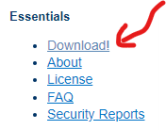
    - 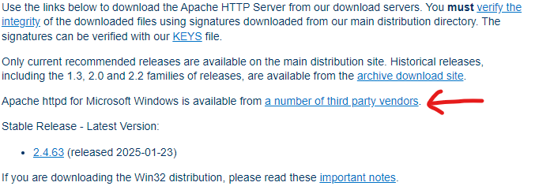

- Once on the next webpage, click on Apache Lounge and download Apache 2.4.63-250207 Win64 zip file:
  - 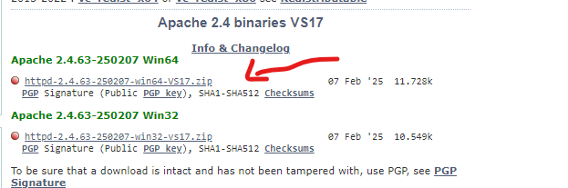

- Once the file is downloaded, unzip it and save it somewhere that is easy to remember (i.e. Desktop or a New Folder):
  - 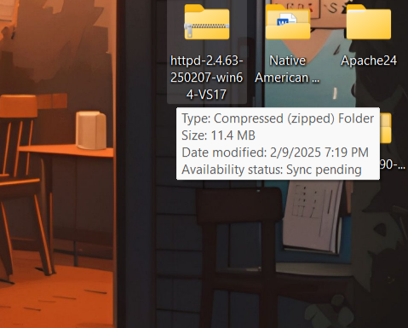
  - 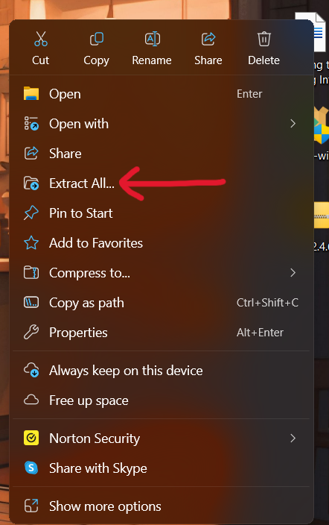

- Once the file has been unzipped, go to the Apache24 folder and once inside, click on the bin file:
  - 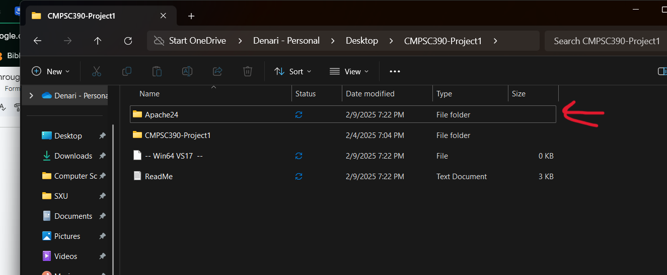
  - 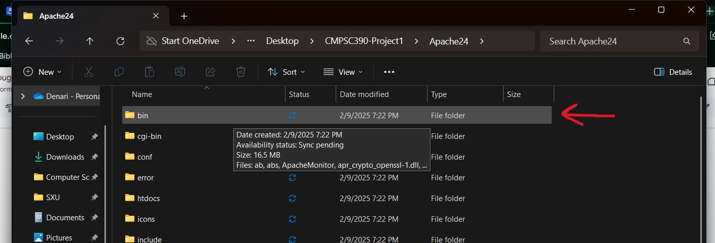

- Inside of the bin folder you will see an application called “httpd” which you will install via Command Prompt on your computer.
  - 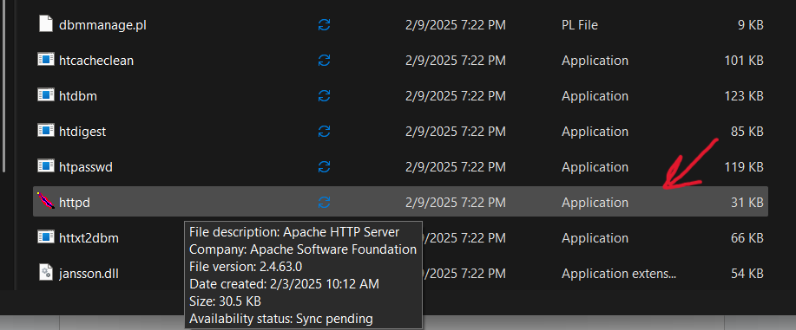
  - 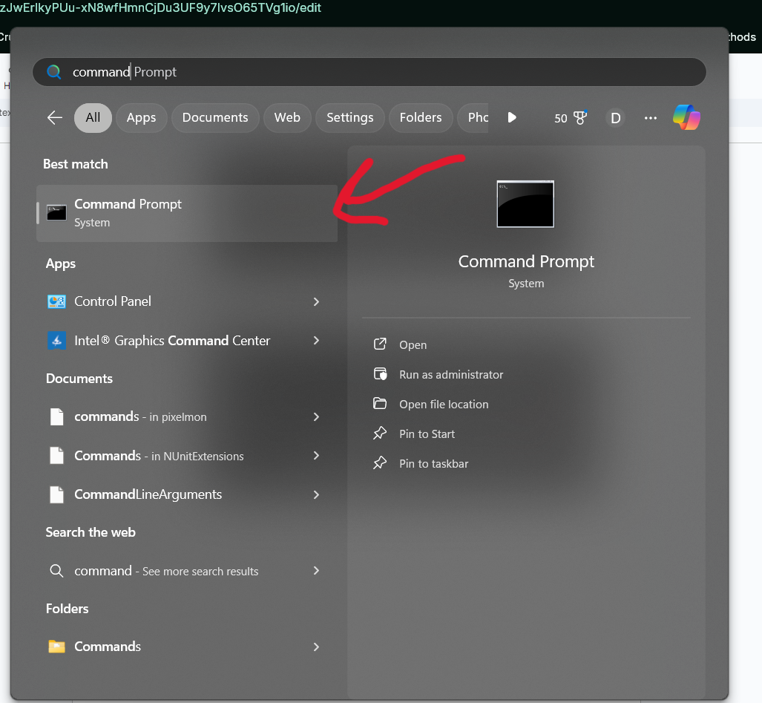
    - When running Command Prompt, be sure to open as administrator.

- Once the command prompt is opened, copy and paste the directory of Apache24\bin
  - 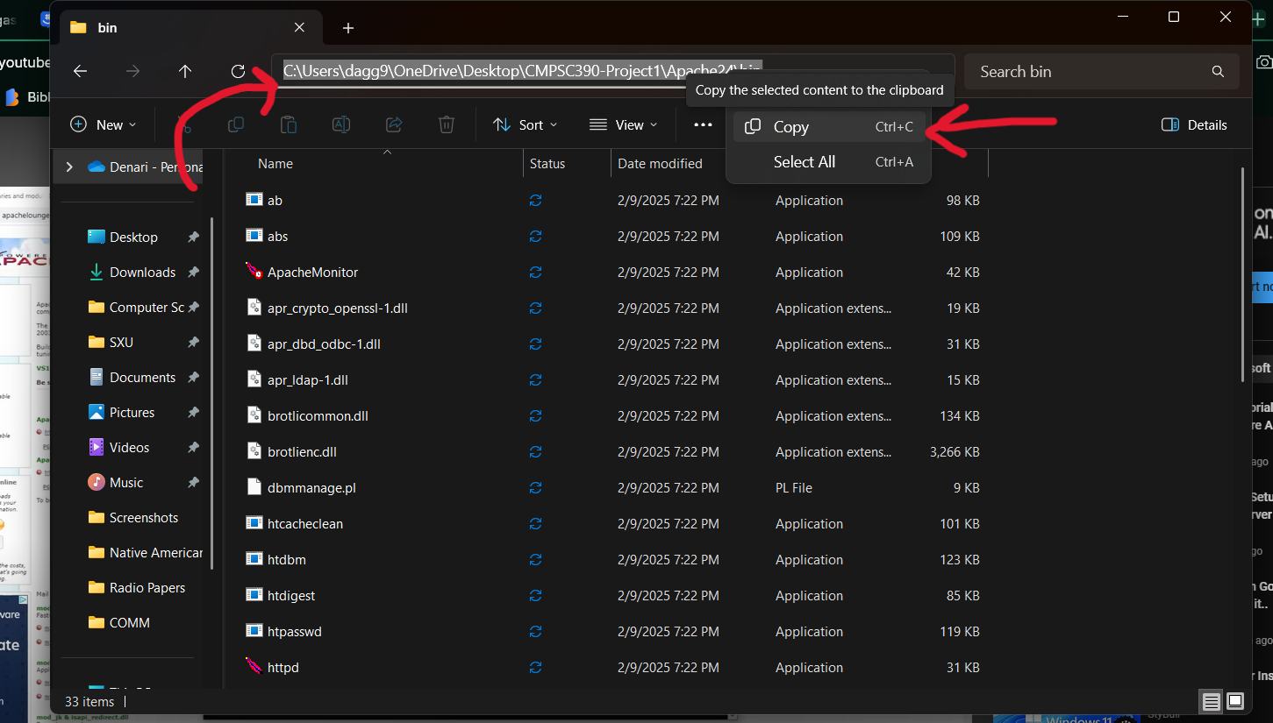
- Inside of the command prompt, type “cd” and the name of the copied directory.
  - 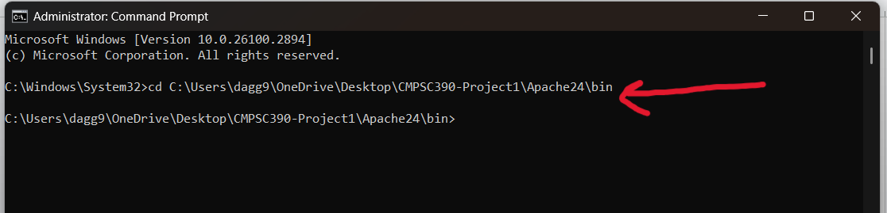

- Once inside the directory, type “httpd -k install” to install the service onto your computer:
  - 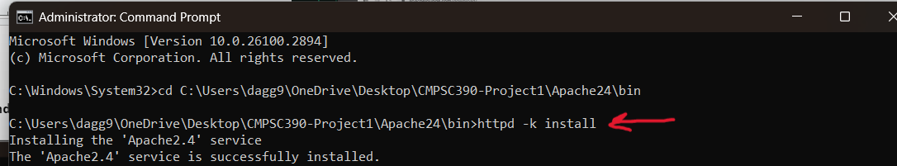

    - If prompted to allow access by Windows Defender Firewall, just click on “Allow Access”.

    - To check if the services were installed, type “services” into the windows search bar and click on it to see if the service has been installed.
      - 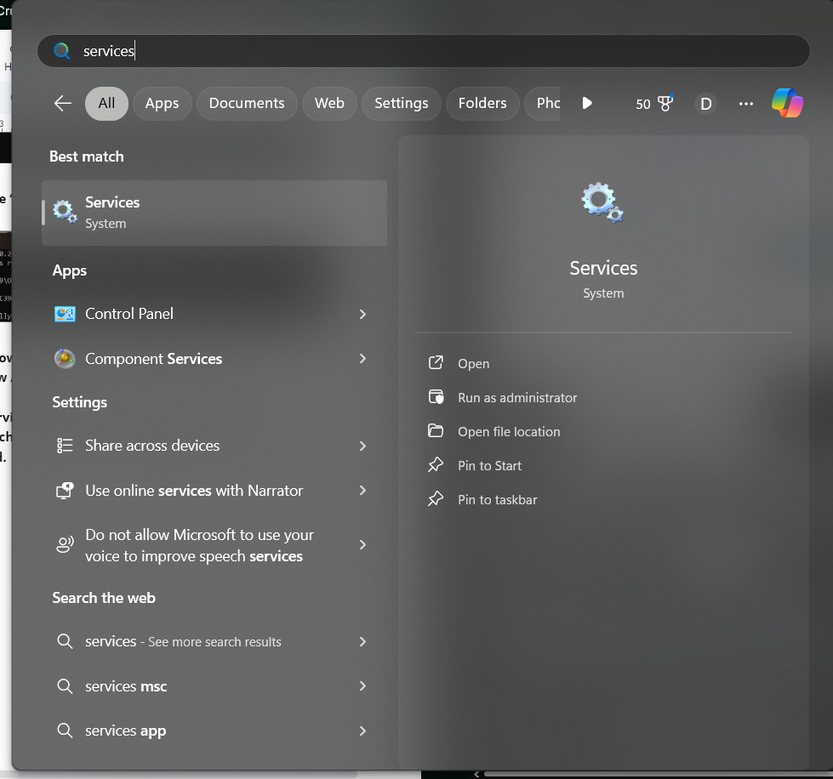
      - 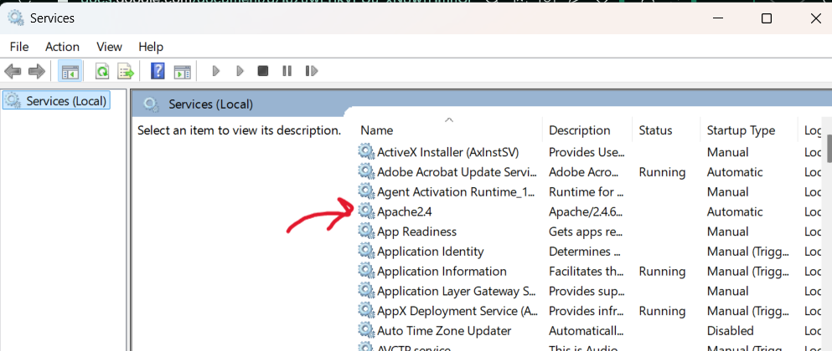

- On the service page, click on Apache24 and set its status to running by starting the service:
  - 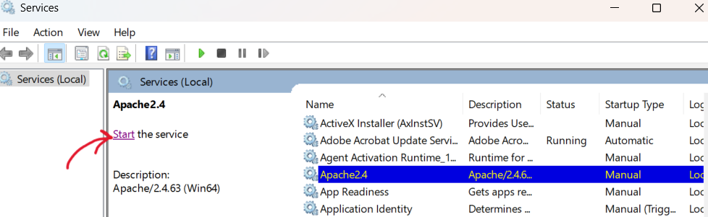
    - To ensure that the service is running, the status of Apache24 should be “Running”.

- To check whether the service is running or not, go to the web address bar and type “127.0.0.1” which should display a screen saying “It works!”
  - 

- Once everything is running perfectly, you can go back to the Apache24 file and access the index where you would be able to code and create the webpage:
  - 
   